**Live Free**

**Every Tuesday**

**June 18 – July 17, 2018**

**11:00 – 3:30 pm**

Casstown United Methodist Church

102 Center St ● Casstown, Ohio

937-339-4828

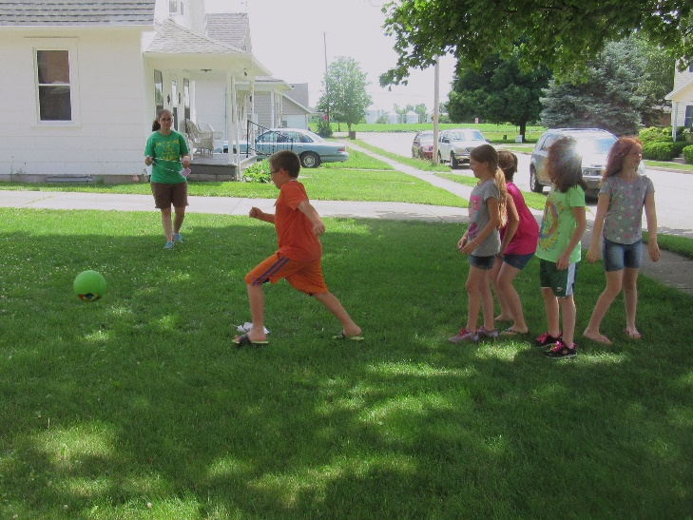

**Live Free** is a **FREE** summer program that offers lunch and snack, reading, crafts, games, sports, service projects, and stories of hope. The meals follow the Ohio Department of Education’s Summer Food Program.

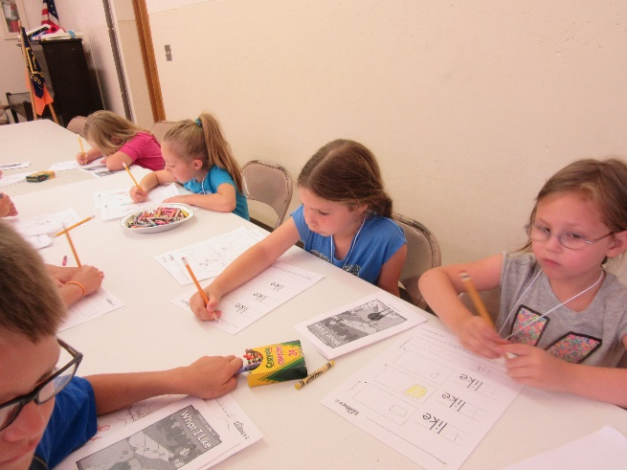**Live Free** is a **FREE** program for kids enter kindergarten through 6th grade. Sign up by sending this registration form back to the church (PO Box 203, Casstown, OH 45312). For more information, call the church office at 937-339-4828.

**Meeting dates are: *June 19, June 26, July 3, July 10, and July 17***

**Live Free Registration Form - 2018**

**Please turn in registration to the Casstown Church Office**

**PO Box 203, Casstown, Ohio 45312**

Name: _________________________Birthday: ____________________

Address: ___________________________________________________

City: _________________________________ Zip Code: _____________

Age: ______________ Grade last completed: ______________________

Siblings Attending: ___________________________________________

Home Church: ______________________________________________

Home Phone: _______________________________________________

Parent/Guardian Cell Phone: ___________________________________

Parent/Guardian Name: _______________________________________

Emergency Contact Name: ____________________________________

Emergency Phone: __________________________________________

Allergies (food etc.) or other Medical Conditions: _________________________________________________________________________________________________________________________________________________________________________________

Person Dropping Off: _________________________________________

Person Picking Up: ___________________________________________

I give my permission for the Casstown UMC, Live Free or Miami Valley District to use pictures of my children on their website or in news articles in reference to the Live Free Program.

Signature of Parent/Guardian___________________________________

Date ______________________________________________________